**Cura5.3-Neptune configuration add step**

catalog

● Tips： 1

● Reference links 1

● Neptune model add method 2

Neptune series machine configuration method 1： 2

Neptune series machine configuration method 2: 4

● FAQ 5

## Tips：

At present, there is a problem with the 'tree' support of cura5.3 version. When slicing a complex model, it may not be able to be sliced after enabling the support.(The default support is Tree in cura 5.3).In this case, please try to use the 'normal' support.

## Reference links

Cura5.3 Download url: <https://github.com/Ultimaker/Cura/releases>

Download the configuration file ：[https://github.com/NARUTOfzr/Cura-Neptune-TEST](https://github.com/NARUTOfzr/Cura5.0-Neptune-TEST)

## Neptune model add method

**Note：**Only one method can be used.

### Neptune series machine configuration method 1：

Applicable to Mac system and Windows system.

Open ”resources” folder, then copy files below.

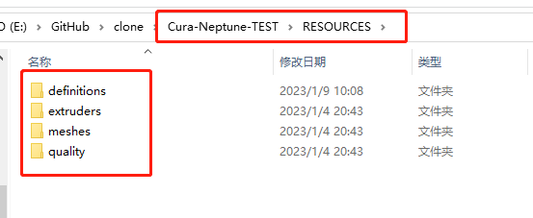

Fire up Cura5.3, head to help→Show Configuration Folder

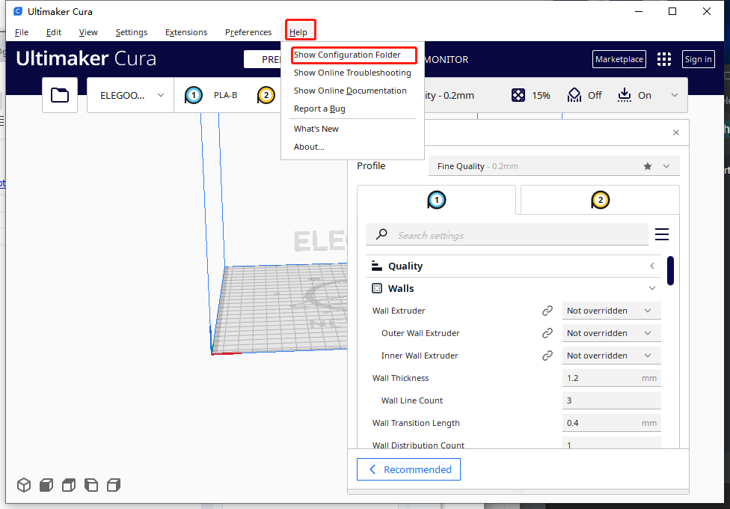

Click the blank area and paste the files. Merge folders then open cura.

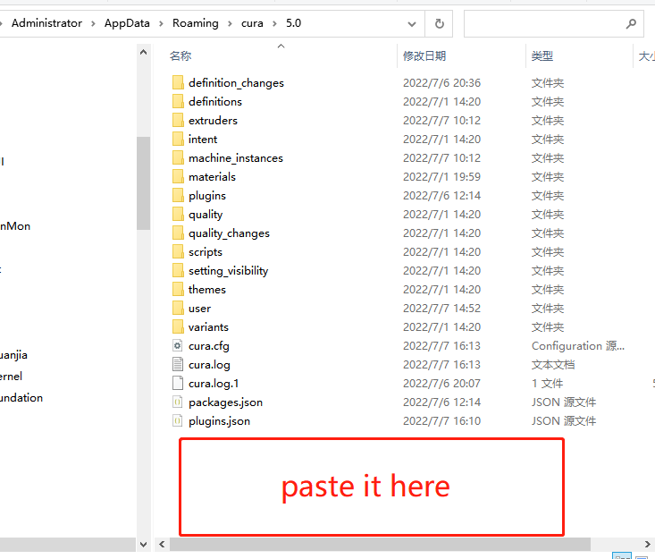

### Neptune series machine configuration method 2:

Note: By testing the method doesn't seem to work on the MacBook.

1.Install cura5.3 and remember the installation directory.

2.Find this folder in the installation directory, click on the blank space, then paste the copied "resources" folder into the current directory, and merge the "resources" folder.

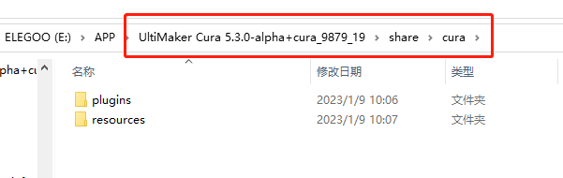

3.Restart "Ultimaker-Cura-5.3" to see related ELEGOO-NEPTUNE series models.

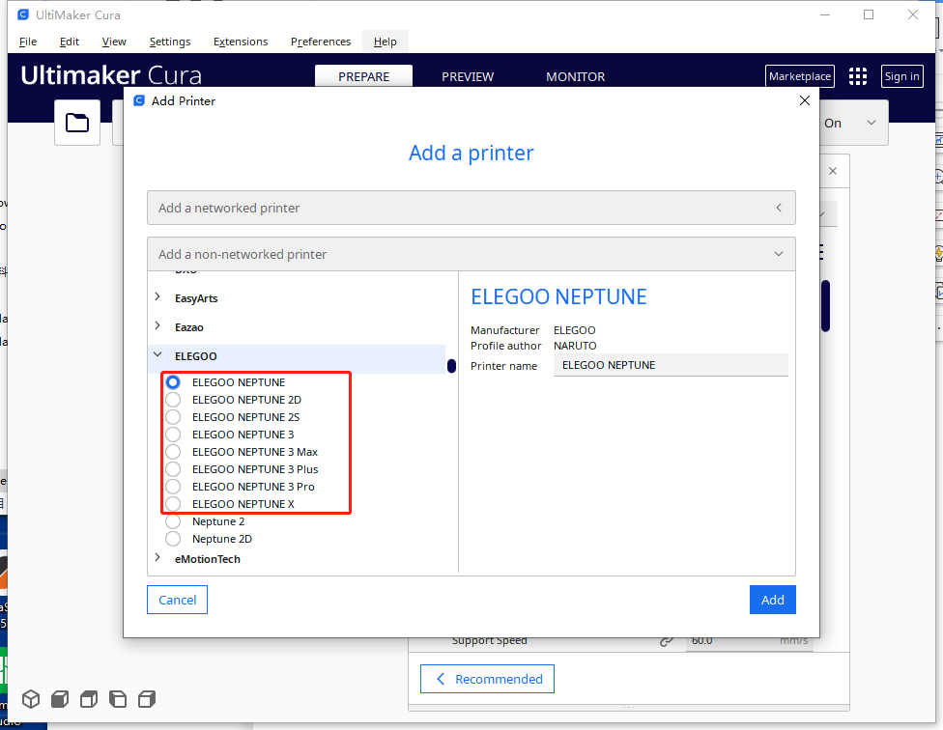

## FAQ

If you have any questions you can find methods or ask questions here:

<https://github.com/NARUTOfzr/Cura-Neptune-TEST/issues>